**Inclass Programming Assignment - 3.1**

**Github Link:** <https://github.com/Viditha2277/DSA-5710/tree/main/Assignment%203.1>

**Description:**

* Reading the CSV file ‘data.csv’

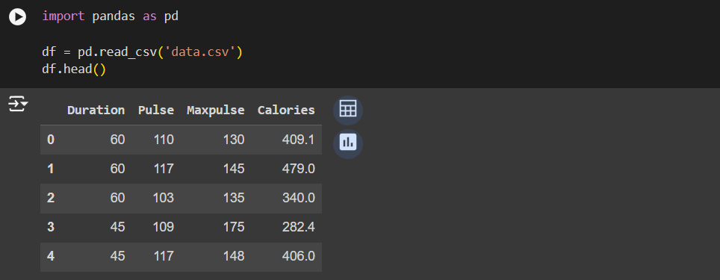

**Description:**

* Showing the basic statistical description about the data

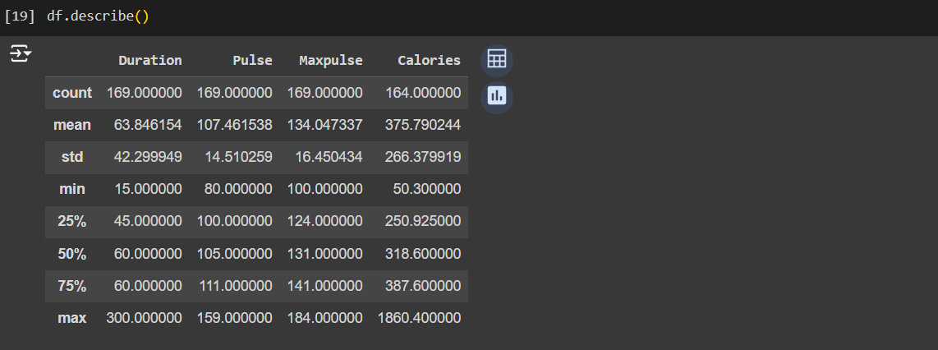

**Description:**

* Checking if the data has null values and replacing the null values with the mean

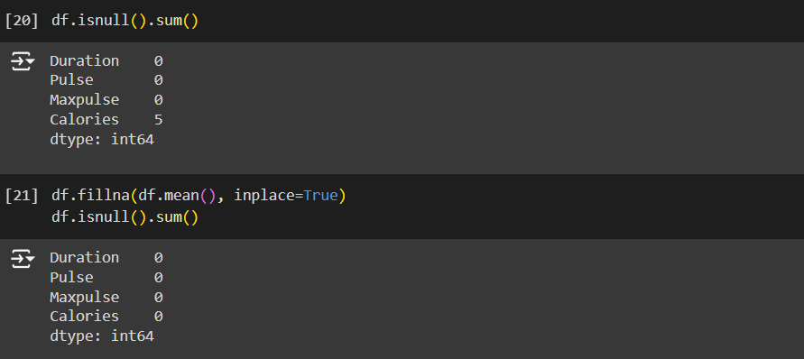

**Description:**

* Selecting at least two columns and aggregating the data using: min, max, count, mean.

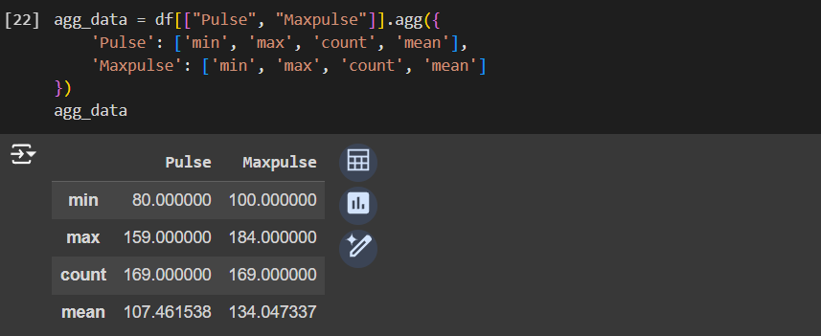

**Description:**

* Filtering the dataframe to select the rows with “Calories” values between 500 and 1000.

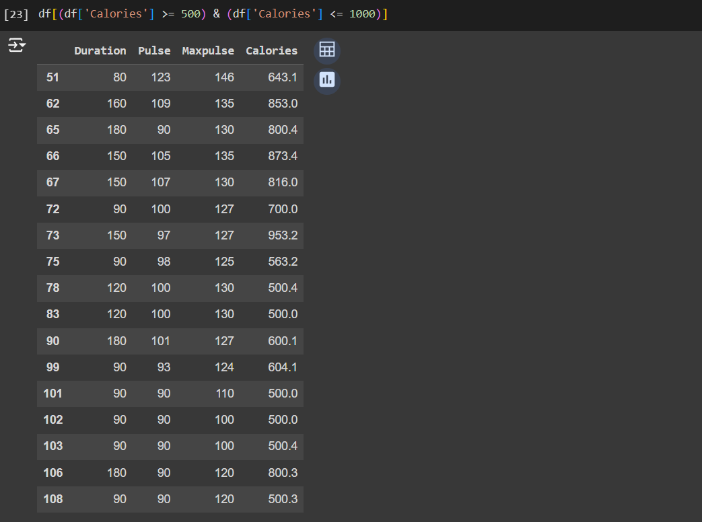

**Description:**

* Filtering the dataframe to select the rows with “Calories” values > 500 and “Pulse” < 100.

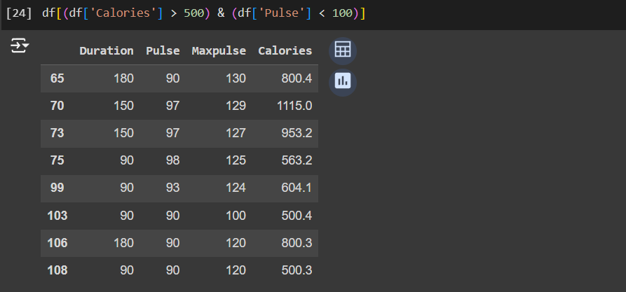

**Description:**

* Creating a new “df_modified” dataframe that contains all the columns from df except for “Maxpulse”.

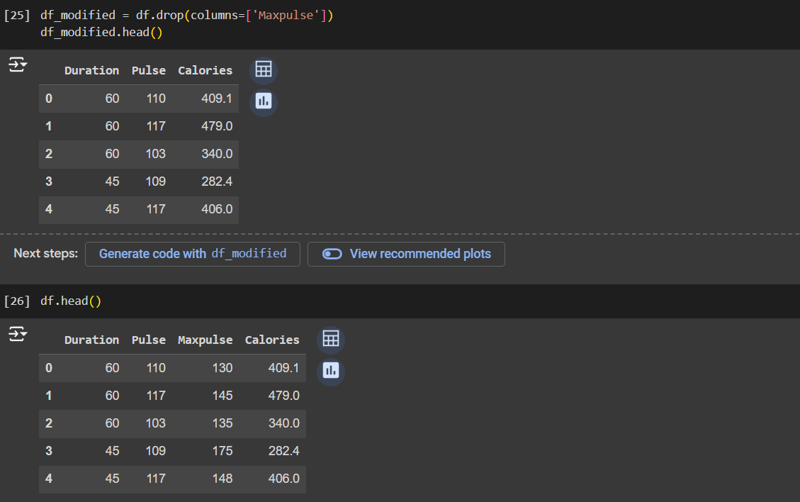

**Description:**

* Deleting the “Maxpulse” column from the main df dataframe.

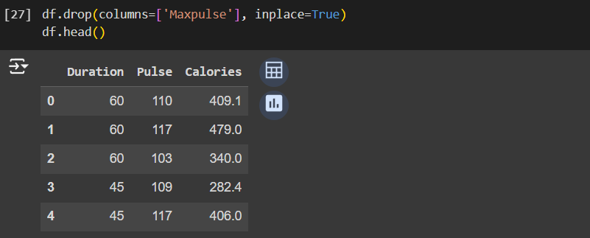

**Description:**

* Converting the datatype of “Calories” column to int datatype.

